**TASK 4**

1. How to compare two JSON have the same properties without order?
2. var obj1={name:”person1”, age 5};
3. var obj2={age:5,name:”person1”};

**Code ::**

// Getting input via STDIN

const readline = require("readline");

const inp = readline.createInterface({

input: process.stdin

});

const userInput = [];

inp.on("line", (data) => {

userInput.push(data);

});

inp.on("close", () => {

var obj1={

"name":"Person1",

"age":"5"

}

var obj2={

"age":"5",

"name":"Person1"

}

console.log(_.isEqual(obj1,obj2));

});

1. **Use the rest countries API URL ->** [**https://restcountries.eu/rest/v2/all**](https://restcountries.eu/rest/v2/all) **and display all country flags in the console.**

**Code::**

var request=new XMLHttpRequest();

request.open("GET","https://restcountries.com/v2/all");

request.send();

request.onload=function(){

var result=JSON.parse(request.response);

    console.log(result);

    for(let i=0; i<result.length; i++){

        console.log(result[i].flags);

}

}

**Output :**

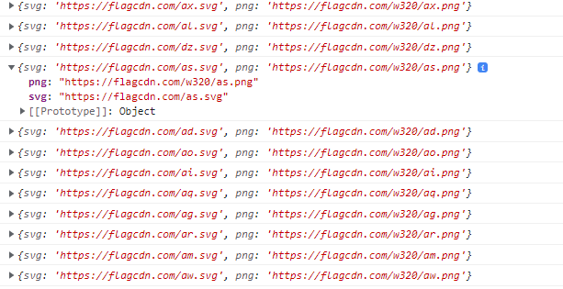

1. **Use the same rest countries and print all countries names,regions,subregion and populations.**

**Code ::**

var request=new XMLHttpRequest();

request.open("GET","https://restcountries.com/v2/all");

request.send();

request.onload=function(){

var result=JSON.parse(request.response);

    console.log(result);

    for(let i=0; i<result.length; i++){

        console.log(result[i].name);

        console.log(result[i].region);

        console.log(result[i].subregion);

        console.log(result[i].population);

}

}

**Output :**

